**STAT 40001/STAT 50001 Statistical Computing Fall 2024**

**Lab-13**

1. Thirteen Honda Accord are chosen to study the gas mileage. Below is the mpg for these vehicles.

27 26 31 30 30 28 26 24 30 30 23 30 23

Perform a test to see whether the data is coming from a normal distribution.

> Q1 = scan()

1: 27 26 31 30 30 28 26 24 30 30 23 30 23

14:

Read 13 items

> Q1

[1] 27 26 31 30 30 28 26 24 30 30 23 30 23

> shapiro.test(Q1)

Shapiro-Wilk normality test

data: Q1

W = 0.86289, p-value = 0.04207

> cat("Reject the null hypothesis i.e. Not from a Normal Distribution")

Reject the null hypothesis i.e. Not from a Normal Distribution

> # can also be verified by

> qqnorm(Q1)

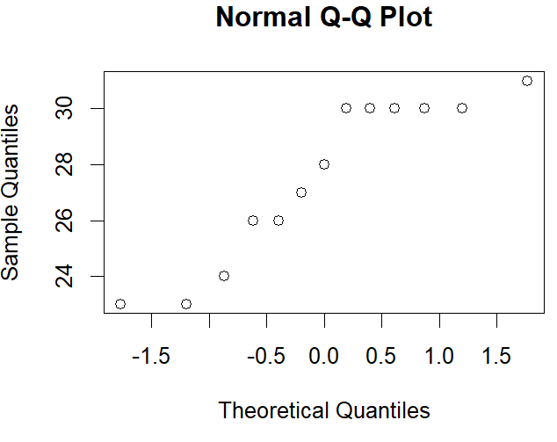

1. An article at Mobilize.org reported that the median credit-card balance for undergraduate students was $1770 for those who carried a balance from month to month. A professor at a community college believes that the median credit-card balance of students at his college is different than $1770. To test this hypothesis, he obtains a random sample of 20 students enrolled at the college who carry a credit-card balance from month to month and asks them to disclose their credit-card debt. The results of the survey are presented in Table 3 in dollars. Do the data indicate that the median credit-card debt of students at the professor's college differs from $1770 at the α=0.05 level of significance?

|  |  |  |  |
| --- | --- | --- | --- |
| 6000 | 870 | 1530 | 1660 |
| 1060 | 1790 | 1630 | 3180 |
| 2180 | 2370 | 1800 | 2170 |
| 1210 | 410 | 1720 | 1270 |
| 570 | 1050 | 2320 | 1120 |

> Q2 = scan()

1: 6000 870 1530 1660

5: 1060 1790 1630 3180

9: 2180 2370 1800 2170

13: 1210 410 1720 1270

17: 570 1050 2320 1120

21:

Read 20 items

> Q2

[1] 6000 870 1530 1660 1060 1790 1630 3180 2180 2370 1800 2170 1210 410 1720 1270 570 1050 2320 1120

> shapiro.test(Q2)

Shapiro-Wilk normality test

data: Q2

W = 0.77128, p-value = 0.0003323

> cat("Reject the null hypothesis i.e. Not from a Normal Distribution")

Reject the null hypothesis i.e. Not from a Normal Distribution

> install.packages("PASWR")

> library(PASWR)

> SIGN.test(Q2, md = 1770, conf.level = 0.9)

One-sample Sign-Test

data: Q2

s = 8, p-value = 0.5034

alternative hypothesis: true median is not equal to 1770

90 percent confidence interval:

1191.352 1876.665

sample estimates:

median of x

1645

Achieved and Interpolated Confidence Intervals:

Conf.Level L.E.pt U.E.pt

Lower Achieved CI 0.8847 1210.000 1800.000

Interpolated CI 0.9000 1191.352 1876.665

Upper Achieved CI 0.9586 1120.000 2170.000

> qqnorm(Q2)

|  |
| --- |
| > cat("Fail to reject the null hypothesis i.e. we have no evidence to conclude that the median pay differ by $1770")  Fail to reject the null hypothesis i.e. we have no evidence to conclude that the median pay differ by $1770 |
|  |
| |  | | --- | | > | |

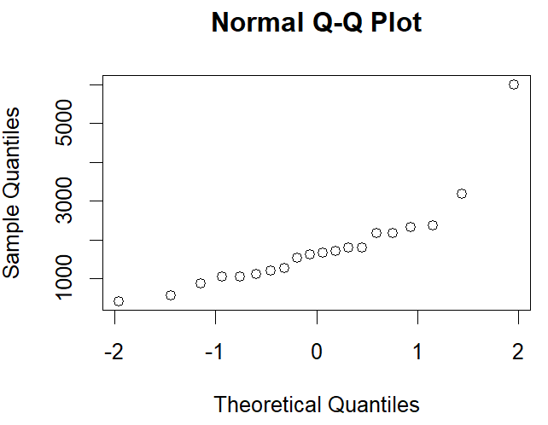

1. The exec.pay data in UsingR library contains data on salaries of CEOs at 199 top companies in the United States. The amount are in $10,000s. Do a sign test to determine whether the median pay is more than $220,000.

|  |
| --- |
| > install.packages("UsingR")  > library(UsingR)  > data("exec.pay")  > head(exec.pay)  [1] 136 74 8 38 46 43  > summary(exec.pay)  Min. 1st Qu. Median Mean 3rd Qu. Max.  0.00 14.00 27.00 59.89 41.50 2510.00  > shapiro.test(exec.pay)  Shapiro-Wilk normality test  data: exec.pay  W = 0.19352, p-value < 2.2e-16  > cat("Reject the null hypothesis, i.e. not a normal distribution")  Reject the null hypothesis, i.e. not a normal distribution  > library(PASWR)  > SIGN.test(exec.pay, md = 22, alt = "greater")  One-sample Sign-Test  data: exec.pay  s = 113, p-value = 0.008506  alternative hypothesis: true median is greater than 22  95 percent confidence interval:  23 Inf  sample estimates:  median of x  27  Achieved and Interpolated Confidence Intervals:  Conf.Level L.E.pt U.E.pt  Lower Achieved CI 0.9407 23 Inf  Interpolated CI 0.9500 23 Inf  Upper Achieved CI 0.9557 23 Inf  > cat("Reject the null hypothesis i.e. median pay is more than $220000")  Reject the null hypothesis i.e. median pay is more than $220000 |
|  |
| |  | | --- | | > | |